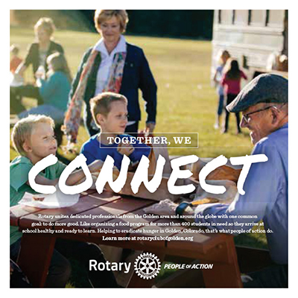

Join Rotary’s 1.4 million neighbors, friends, leaders, and problem-solvers who see a world where people unite and take action to create lasting change – across the globe, in our communities, and in ourselves.

Your time, energy, and a passion to improve your world are all you need to get involved with Rotary.
Become one of Rotary’s people of action or explore the many opportunities we have for anyone — whatever your age or interest — who wants to improve lives in communities near and far. Connect with a local club to find out how you can get involved.

